**MINI PROJECT TITLE: SORTING GAME**

**Subject: Object Oriented Programming Methodology -Lab**

**S. E. EXTC B**

**Under the guidance of**

**Ms. K. Priya Karunakaran**

**By**

**PRADEEP PATWA-02**

**ABHISHEK RAJPUT-05**

**SUMIT RANA-06**

**KAIVAN SHAH-24**



Department of Electronics and Telecommunication

St. Francis Institute of Technology

University of Mumbai

2019-2020

TABLE OF CONTENTS

|  |  |  |
| --- | --- | --- |
| Chapter | Contents | Page No. |
| 1 | INTRODUCTION | 3 |
| 2 | PROBLEM DEFINITION | 4 |
| 3 | MODULES | 5 |
| 4 | IMPLEMENTATION | 6 |
| 5 | RESULTS | 12 |
| 6 | CONCLUSIONS AND FUTURE SCOPE | 15 |
| 7 | REFERENCES |  |

1. INTRODUCTION

1. Sorting Game is a simple java-based game in which random numbers are generated and the player has to sort them in a particular order.
2. We are using the NetBeans IDE (v 8.0.1) and Javafx to create a GUI to make the game more interactive and attractive.
3. We have currently provided 2 options that is Ascending as well as Descending.
4. We have also added different difficulty levels, player can unlock a new level only after correctly completing the last level.
5. Score calculation are some additional features that we have added. Leader board, Timer and Data collection are some of the additional features we are planning to add.

2. PROBLEM DEFINITION

1.Register the registration form if already registered then Log in directly.

2.According to the choice select your type of sorting i.e. ascending or descending.

Level 1 frame will appear with random numbers. The player has to sort these random numbers in a chronological order such as ascending or descending, the choice will be already given before.

3.Level 2 frame will appear in which, random numbers will appear again with increase in difficulty level, to increase the difficulty level we are making use of decimal numbers using a double array.

The score will be displayed in the score frame where there will be total score of Level 1 and 2.

3. MODULES

Keep player records maintain scores from a display an unsorted list of n numbers.

Choose the orders: ascending / descending. Also choose the difficulty level 1 – 5. 1 means more time less numbers and 5 means less time and more numbers. User is given slots to enter the number in correct order.

4.IMPLEMENTATION (CODE)

Registration Code

import javax.swing.JFrame;

import javax.swing.JOptionPane;

import java.awt.event.WindowEvent;

import java.awt.Toolkit;

public class geez extends javax.swing.JFrame {

public geez() {

initComponents();

}

private void jLabelCloseMouseClicked(java.awt.event.MouseEvent evt) {

System.exit(0);

}

private void jLabelRegisterMouseClicked(java.awt.event.MouseEvent evt) {

shhh lgfa = new shhh();

lgfa.setVisible(true);

lgfa.pack();

lgfa.setLocationRelativeTo(null);

lgfa.setDefaultCloseOperation(JFrame.EXIT_ON_CLOSE);

this.dispose();

}

private void jButtonRegisterActionPerformed(java.awt.event.ActionEvent evt) {

if (password.getText().equals(confirmpassword.getText())){

shhh lgf = new shhh();

lgf.setVisible(true);

lgf.pack();

lgf.setLocationRelativeTo(null);

lgf.setDefaultCloseOperation(JFrame.EXIT_ON_CLOSE);

this.dispose();}

else

{

JOptionPane.showMessageDialog(null,"PASSWORD AND CONFIRMED PASSWORD SHOULD BE SAME"," ",JOptionPane.ERROR_MESSAGE);

password.setText(null);

confirmpassword.setText(null);

username.setText(null);

emailid.setText(null);

firstname.setText(null);

}

}

public static void main(String args[]) {

java.awt.EventQueue.invokeLater(new Runnable() {

public void run() {

new geez().setVisible(true);

}

});

Login Code

private void jLabelRegisterMouseClicked(java.awt.event.MouseEvent evt) {

geez gf = new geez();

gf.setVisible(true);

gf.pack();

gf.setLocationRelativeTo(null);

gf.setDefaultCloseOperation(JFrame.EXIT_ON_CLOSE);

this.dispose();

}

private void jLabelCloseMouseClicked(java.awt.event.MouseEvent evt) {

System.exit(0);

}

public static void main(String args[]) {

java.awt.EventQueue.invokeLater(new Runnable() {

public void run() {

new shhh().setVisible(true);

geez g1 = new geez();

}

});

}

Level 1 Code

import java.util.Random;

import java.util.concurrent.ThreadLocalRandom;

import java.util.logging.Level;

import java.util.logging.Logger;

import javax.swing.JFrame;

import javax.swing.JLabel;

import javax.swing.JOptionPane;

public class level11 extends javax.swing.JFrame {

public level11() {

initComponents();

int[] a = { 1, 2, 3, 4, 5, 6, 7, 8, 9, 10 };

String s = new String();

Random rnd = ThreadLocalRandom.current();

for (int i = a.length - 1; i > 0; i--)

{

int b = rnd.nextInt(i + 1);

int temp = a[b];

a[b] = a[i];

a[i] = temp;

}

for (int i = 0; i < a.length; i++)

{

s = s.concat(" " + a[i]);

}

ez.setText(s);

use.getText();

}

private void jButton3ActionPerformed(java.awt.event.ActionEvent evt) {

middle g3 = new middle();

g3.setVisible(true);

g3.pack();

g3.setLocationRelativeTo(null);

g3.setDefaultCloseOperation(JFrame.EXIT_ON_CLOSE);

this.dispose();

}

private void jLabelCloseMouseClicked(java.awt.event.MouseEvent evt) {

System.exit(0);

}

private void jButton2ActionPerformed(java.awt.event.ActionEvent evt) {

String z = "1 2 3 4 5 6 7 8 9 10";

String k = "10 9 8 7 6 5 4 3 2 1";

String e23 = use.getText();

System.out.println(e23);

if (e23.equals(z) || e23.equals(k))

{System.out.println("Equal");

scor();

Lvl2 gf8=new Lvl2();

gf8.setVisible(true);

gf8.pack();

gf8.setLocationRelativeTo(null);

gf8.setDefaultCloseOperation(JFrame.EXIT_ON_CLOSE);

this.dispose();

}

else

{

JOptionPane.showMessageDialog(null,"YOUR ANSWER IS INCORRECT"," ",JOptionPane.ERROR_MESSAGE);

}

}

Level 2 Code

import java.util.Random;

import java.util.concurrent.ThreadLocalRandom;

import javax.swing.JFrame;

import javax.swing.JOptionPane;

public class Lvl2 extends javax.swing.JFrame {

int score;

public Lvl2(int s) {

score=s;

initComponents();

double[] ai = { 11.3, 2.28, 3.6, 3.06, 1.3, 2.23, 2.7, 3.82, 9.989, 10.36 };

String si = new String();

Random rnd = ThreadLocalRandom.current();

for (int i = ai.length - 1; i > 0; i--)

{

int b = rnd.nextInt(i + 1);

double temp = ai[b];

ai[b] = ai[i];

ai[i] = temp;

}

for (int i = 0; i < ai.length; i++)

{

si = si.concat(" " + ai[i]);

}

tom.setText(si);

}

Lvl2() {

throw new UnsupportedOperationException("Not supported yet."); //To change body of generated methods, choose Tools | Templates.

}

private void jButton4ActionPerformed(java.awt.event.ActionEvent evt) {

middle g4 = new middle();

g4.setVisible(true);

g4.pack();

g4.setLocationRelativeTo(null);

g4.setDefaultCloseOperation(JFrame.EXIT_ON_CLOSE);

this.dispose();

}

private void jLabelCloseMouseClicked(java.awt.event.MouseEvent evt) {

System.exit(0);

}

private void jButton2ActionPerformed(java.awt.event.ActionEvent evt) {

String ko = "1.3 2.23 2.28 2.7 3.06 3.6 3.8 9.89 10.36 11.3";

String k1 = "11.3 10.36 9.89 3.8 3.6 3.06 2.7 2.28 2.23 1.3";

String e24 = jerry.getText();

System.out.println(e24);

if (e24.equals(ko) || e24.equals(k1))

{System.out.println("Equal");

score gf8=new score();

gf8.setVisible(true);

gf8.pack();

gf8.setLocationRelativeTo(null);

gf8.setDefaultCloseOperation(JFrame.EXIT_ON_CLOSE);

this.dispose();

}

else

{

JOptionPane.showMessageDialog(null,"YOUR ANSWER IS INCORRECT"," ",JOptionPane.ERROR_MESSAGE);

}

}

RESULTS

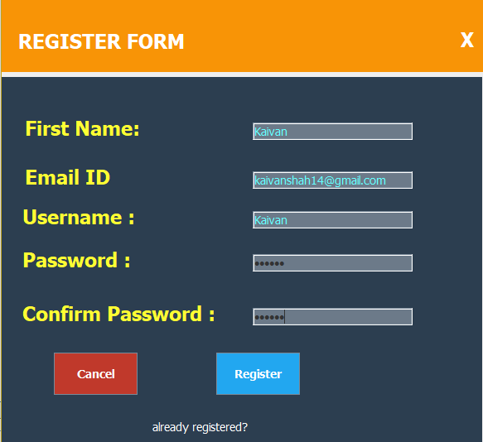

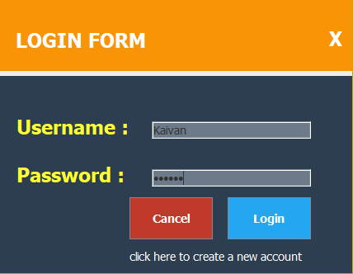

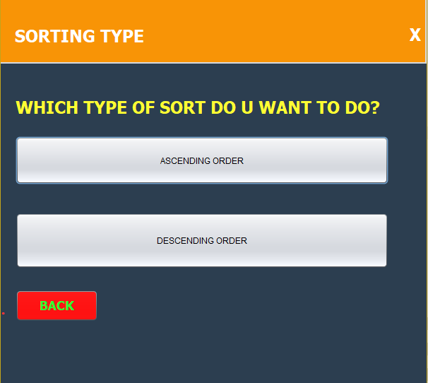

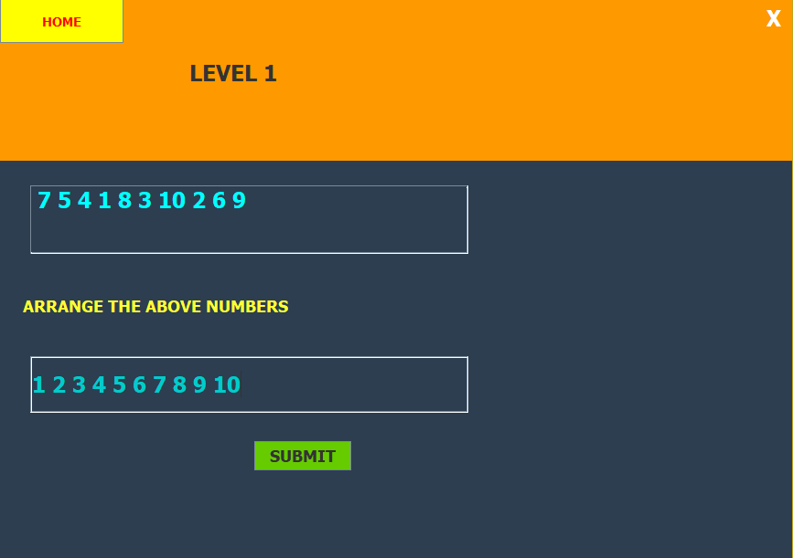

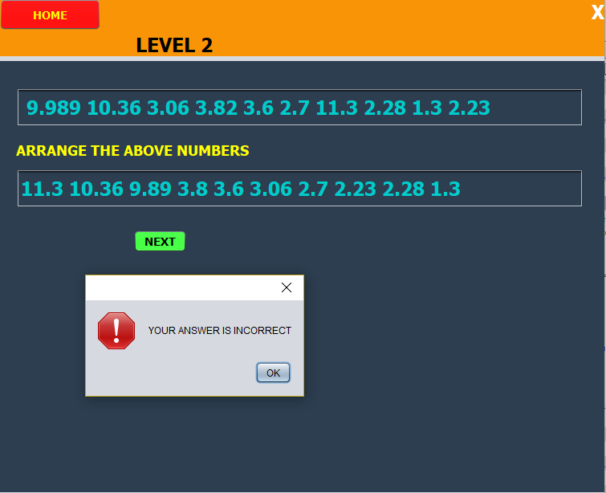

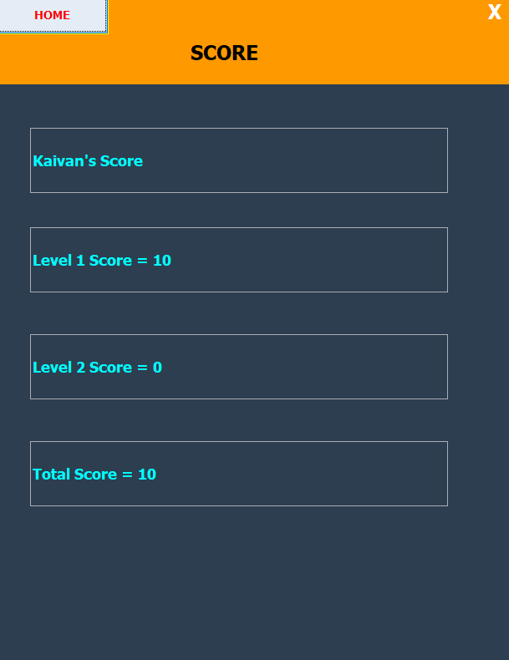

6. CONCLUSION AND FUTURE SCOPE

1. We created this game for the entertainment purpose and also learned about Javafx and its application, which is useful for project building and app development purposes.

2. By playing this game one can improve its mathematical and observational skills.

3.In future, we can add more levels and make it more entertaining. We can also make use of timer to make it more intense.

4. Our project helped us to understand the basic as well as advance features and working of JavaFx.

5. In the future, we can also publish such an app which will help students/players to master their Mathematical and Observation skills.

7. REFERENCES

(List of the books or websites you referred)

1. YouTube (New Boston Channel)
2. [www.geeksforgeeks.com](http://www.geeksforgeeks.com)
3. Lab Experiments (For Random Numbers)